**IT24102821**

**PS Lab 05**

**Q1).**

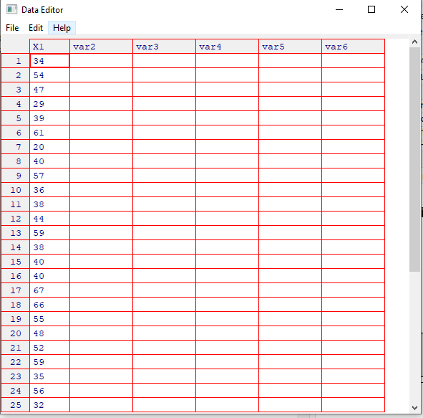

**Q2.**

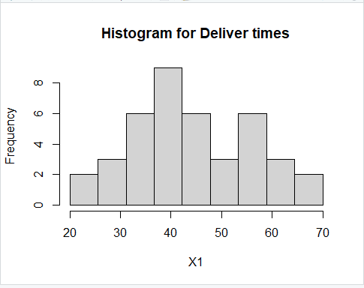

**Q3.**

**The distribution is approximately symmetric and bell-shaped, resembling a normal distribution.**

**Q4.**

